  Healthcare Clinic  Healthcare Management System | 8/28/2026  Tejal Kanti -ST10513267  Web Development - WEDE

Table of Contents
1. Organization Overview 3
Name of Organization: 3
Mission Statement of the Organization: 3
Vision of the Organization: 3
Target Audience of the Organization: 3
History of Organization: 4
2. Website Goals and Objectives 5
Website Goals: 5
Key Performance Indicators (KPIs): 6
3. Proposed Website Features and Functionalities 7
The Key Features with its functionalities: 9
4. Design and User Experience 12
The Design Aesthetic and Branding 12
The Color Scheme 12
The Typography 13
Layout and Design 13
User Experience (UX) Considerations 14
Low-Fidelity Wireframes 15
5. Technical Requirements 19
Programming Languages and Frameworks 19
Hosting and Domain Requirements 20
File and Folder Structure 21
6. Timeline and Milestones 22
7. Budget 23
8. Site Map 24
9. Logo Design 25
References 26

Table of Figures

Table 1: KPI's Target Table 6
Table 2: The main pages that the website will include 8
Table 3: The Color Palette of the Website 12
Table 4: The type of fonts that will be used in the website 13
Table 5: The Programming Languages and their purpose 19
Table 6: Hosting and Domain Requirements 20
Table 7: Timeline of creating the website 22
Table 8: Budget Estimation for the Website 23

Figure 1: Homepage Wireframe 15
Figure 2: About Us Page Wireframe 16
Figure 3: Services Page Wireframe 16
Figure 4: Enquiry Page Wireframe 17
Figure 5: Contact Page Wireframe 17
Figure 6: Staff Dashboard Page Wireframe 18
Figure 7: File Structure 21
Figure 8: Site Map 24
Figure 9: Logo Design 25

Organization Overview

Name of Organization:
Healthcare Clinic

Mission Statement of the Organization:
To provide accessible, patient-centered primary healthcare supported by efficient and modern digital management systems, ensuring that every patient receives timely and quality care.

Vision of the Organization:
To become the most trusted and preferred community clinic in the region by delivering exceptional healthcare experiences, empowered by innovative technology and a compassionate team.

Target Audience of the Organization:
- Local Patients
  - Community members seeking to learn about clinic services, register as patients, and book appointments online.
- Clinic Administrators
  - Staff responsible for managing patient records, appointments, and general enquiries.
- Doctors / General Practitioners
  - Medical professionals need to access patient information, manage prescriptions, and track consultation queues.
- Clinic Support Staff
  - Nurses and reception staff who manage daily operations, including queue management and medicine inventory. (Shojaei, et al., 2024)

History of Organization:
Healthcare Clinic is a small, privately owned primary healthcare practice established to serve the needs of its local residential community. The clinic was founded on the belief that quality healthcare should be accessible and affordable to all members of the community, regardless of their socioeconomic background.

As a small independent medical practice, Healthcare Clinic operates with a focused team of general practitioners, nurses, and administrative staff. The clinic provides a range of primary healthcare services, including general consultations, prescription management, and preventative care. Over time, the clinic has grown its patient base through word-of-mouth referrals and its commitment to personalized, compassionate care.

Recognizing the increasing demand for digital solutions in healthcare administration, Healthcare Clinic has identified the need to modernize its operations through a dedicated web-based clinic management system. This system will streamline day-to-day administrative tasks, improve patient experience, and enhance overall clinic efficiency. (Carini, et al., 2021)

Website Goals and Objectives

Website Goals:
The primary goals for the Healthcare Clinic website and management system are as follows:
- Establish an Online Presence: Provide the clinic with a professional, credible, and informative online presence that allows patients to access clinic information at any time. (Zhao, et al., 2017)

- Enable Patient Self-Service: Allow existing and prospective patients to view available services, submit enquiries, and initiate appointment bookings through the website. (Zhao, et al., 2017) (Carini, et al., 2021)

- Streamline Clinic Administration: Provide clinic staff and administrators with a centralized digital platform to manage patient registrations, appointments, prescriptions, medicine inventory, and patient queues efficiently. (Zhao, et al., 2017)

- Improve Patient Communication: Offer patients a clear and accessible channel to contact the clinic, ask questions, and receive information about services offered. (Zhao, et al., 2017)

- Demonstrate Front-End Development Competency: Demonstrate a comprehensive range of front-end web development skills using HTML5, CSS3, and JavaScript, including CRUD operations, form validation, Local Storage data management, and responsive design. (Zhao, et al., 2017)

- Reduce Administrative Workload: By digitizing clinic operations, reduce the time staff spend on manual record-keeping and administrative tasks.

Key Performance Indicators (KPIs):

The following KPIs will be used to measure the success of the website:
KPI | Description | Target
Appointment Booking Efficiency | Reduction in average time taken to schedule and confirm patient appointments. | Reduce booking time by 40% compared to manual processes.
Patient Registration Completion Rate | Percentage of new patients who successfully complete the online registration process. | 90% successful completion rate.
Enquiry Response Rate | Number of enquiries submitted through the website's enquiry form. | Minimum of 10 enquiries processed per week.
System Usability Score | Measured through user feedback and testing, assessing ease of navigation and overall usability. | Achieve a usability satisfaction score of 80% or higher.
Low-Stock Alert Effectiveness | Frequency with which medicine inventory low-stock alerts are acted upon within 24 hours. | 95% of alerts are taken within one business day.
Cross-Browser Compatibility | The website functions correctly across major web browsers (Chrome, Firefox, Edge, Safari). | 100% compatibility across all four major browsers.
Table 1: KPI's Target Table

Proposed Website Features and Functionalities
The Healthcare Clinic website will consist of two primary components: a public-facing website and a clinic management system. Together, these components will deliver a comprehensive digital solution for the clinic.

Page | File Name | Description
Homepage | index.html | Hero image, brief clinic introduction, call-to-action buttons, and navigation menu.
About Us | about.html | Clinic history, mission statement, vision statement, and team member profiles.
Services  (OWASP, 2026) | services.html | Detailed descriptions of all clinic services offered, including general consultations, prescription services, and preventative care.
Registration  (OWASP, 2026) | register.html | Register new patients by capturing personal and medical information, edit and update existing patient details as required, search for existing patients by name or patient ID.
Appointment Booking  (OWASP, 2026) | booking.html | Schedule new patient appointments with available doctors, view the daily appointment schedule for all practitioners, cancel or reschedule existing appointments as needed.
Prescription Tracker  (Mbonane, et al., 2023) | tracker.html | Record and store prescribed medications for individual patients, view a comprehensive prescription history for any registered patient, generate print-friendly prescription slips for patients.
Medicine Inventory  (Mbonane, et al., 2023)  (Peter J Gates, 2021) | inventory.html | Add new medicines to the clinic's inventory, track current stock levels for all medicines, receive automated low-stock alerts when stock falls below a defined threshold, update medicine quantities as stock are received or dispensed.
Queue Management  (Mbonane, et al., 2023)  (Peter J Gates, 2021) | queue.html | Display a real-time list of patients currently waiting for consultation, mark a patient's status as In consultation when they are called in, mark a consultation as completed once the patient has been seen.
Staff Dashboard  (Mbonane, et al., 2023)  (Peter J Gates, 2021) | dashboard.html | Total number of registered patients, today's scheduled appointments, current number of medicines are in stock, low-stock notifications requiring immediate attention.
Enquiry | enquiry.html | An online enquiry form allowing patients and visitors to submit service-related questions and requests.
Contact | contact.html | Clinic contact details, embedded map showing clinic locations (minimum two locations), and a contact form.
Table 2: The main pages that the website will include

The Key Features with its functionalities:
Clinic Management System Modules

- Patient Registration: (Carini, et al., 2021) (Shojaei, et al., 2024)
- Register new patients by capturing personal and medical information.
- Edit and update existing patient details as required.
- Search for existing patients by name or patient ID. (NDA)

- Appointment Booking: (Carini, et al., 2021) (Shojaei, et al., 2024)
- Schedule new patient appointments with available doctors.
- View the daily appointment schedule for all practitioners.
- Cancel or reschedule existing appointments as needed.

- Prescription Tracker: (Mbonane, et al., 2023) (Peter J Gates, 2021)
- Record and store prescribed medications for individual patients.
- View a comprehensive prescription history for any registered patient.
- Generate print-friendly prescription slips for patients.
- Have an audit trail report.

- Medicine Inventory: (Mbonane, et al., 2023) (Peter J Gates, 2021)
- Add new medicines to the clinic's inventory.
- Track current stock levels for all medicines.
- Receive automated low-stock alerts when stock falls below a defined threshold.
- Update medicine quantities as stock are received or dispensed and have an audit trail report.

- Queue Management:
- Display a real-time list of patients currently waiting for consultation.
- Mark a patient's status as in consultation when they are called in.
- Mark a consultation as completed once the patient has been seen.

- Staff Dashboard:
- Total number of registered patients.
- Today's scheduled appointments.
- Current number of medicines are in stock.
- Low stock notifications require immediate attention.

Additional System Functionality
- Responsive User Interface:
  - The website and management system will be fully responsive, functioning correctly on desktop computers, tablets, and mobile devices.

- CRUD Operations:
  - All modules will support Create, Read, Update, Delete and audit trail operations.

- Search and Filtering:
  - Users will be able to search and filter patient records, appointments, and inventory items.

- Form Validation:
  - All data entry forms will include client-side validation to ensure accurate and complete data submission.

- Dashboard Statistics and Summary Cards:
  - The dashboard will display key metrics using visually clear summary cards.

- Print-Friendly Documents:
  - The system will support the printing of prescriptions and appointment confirmation slips.

Design and User Experience

The Design Aesthetic and Branding

The design of the Healthcare Clinic website will reflect a clean, professional, and trustworthy aesthetic. The visual identity will be consistent with the clinic's commitment to patient-centered care, using calming and health-associated colors, modern typography, and a straightforward layout that prioritizes clarity and ease of use. (Saad, et al., 2022)

The Color Scheme
Color | Hex Code | Usage
Primary Blue | #1A73E8 | Navigation bar, headings, buttons, and links.
Secondary Green | #34A853 | Call-to-action buttons, success messages, and accent elements.
White | #FFFFFF | Page backgrounds and card backgrounds to ensure readability.
Light Grey | #F5F5F5 | Section backgrounds and alternate rows in tables.
Dark Grey / Charcoal | #333333 | Body text and footer elements.
White | #FFFFFF | Page backgrounds and card backgrounds to ensure readability.
Table 3: The Color Palette of the Website

The Typography
Element | Font | Style
Headings (H1 – H3) | Poppins | Bold (700)
Sub-headings (H4 – H6) | Poppins | Semi-Bold (600)
Body Text | Arial | Regular (400)
Captions and Labels | Arial | Italic (400)
Table 4: The type of fonts that will be used in the website

Font Source: Google Fonts (Poppins); System font stack (Arial).
Base Font Size: 16px for body text, with a modular typographic scale for headings.

Layout and Design

The website will follow a grid-based layout using CSS Flexbox and CSS Grid to ensure consistency and alignment across all pages. (W3Schools., 2024) (Network, 2024)
- Each page will include a consistent header with navigation, a main content area, and a footer with contact information and quick links.
- Card-based components will be used throughout the management system modules to present information in a structured and digestible format.
- Adequate whitespace will be incorporated throughout to reduce visual clutter and improve readability.
- Icons sourced from a reputable free icon library (Font Awesome) will be used to enhance visual communication and aid navigation. (Saad, et al., 2022)

User Experience (UX) Considerations

- Navigation: (Saad, et al., 2022)
  - A clear, fixed navigation bar will be present on all public-facing pages, with clearly labelled links to each section of the website. The management system will use a sidebar navigation panel.

- Accessibility: (Saad, et al., 2022)
  - Sufficient color contrast ratios will be maintained to meet basic accessibility standards.
  - All images will include descriptive alternative text. (WCAG, 2024)

- Mobile Responsiveness: (WCAG, 2024)
  - All pages will be designed with a mobile-first approach, ensuring usability across various screen sizes.

- Call-to-Action Buttons: (WCAG, 2024)
  - Prominent CTA buttons such as Book an Appointment, Contact Us, and Learn More will be placed strategically on the homepage and services pages to guide user behavior.

- Consistency: (WCAG, 2024)
  - Consistent use of colors, typography, button styles, and spacing across all pages will reinforce the clinic's brand identity.

Low-Fidelity Wireframes

The following low-fidelity wireframes outline the layout and information hierarchy for each key page:
Color | Hex Code | Usage
Primary Blue | #1A73E8 | Navigation bar, headings, buttons, and links.
Secondary Green | #34A853 | Call-to-action buttons, success messages, and accent elements.
White | #FFFFFF | Page backgrounds and card backgrounds to ensure readability.
Light Grey | #F5F5F5 | Section backgrounds and alternate rows in tables.
Dark Grey / Charcoal | #333333 | Body text and footer elements.
White | #FFFFFF | Page backgrounds and card backgrounds to ensure readability.

Homepage (index.html)
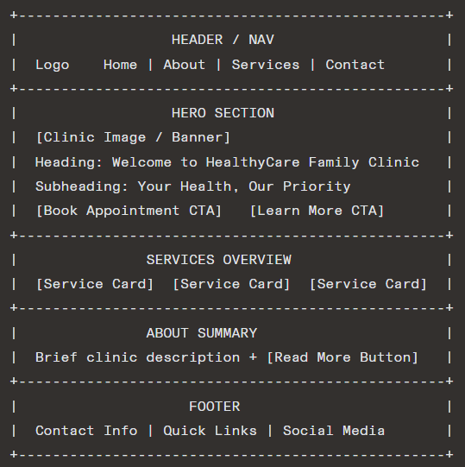
Figure 1: Homepage Wireframe

About Us (about.html)
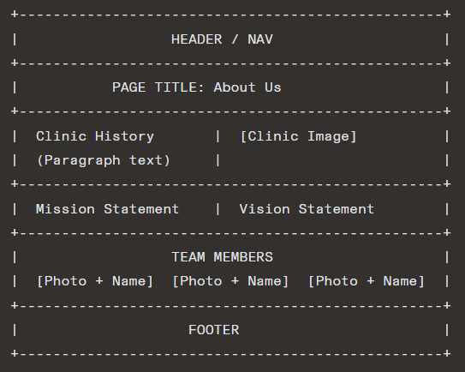
Figure 2: About Us Page Wireframe

Services (services.html)
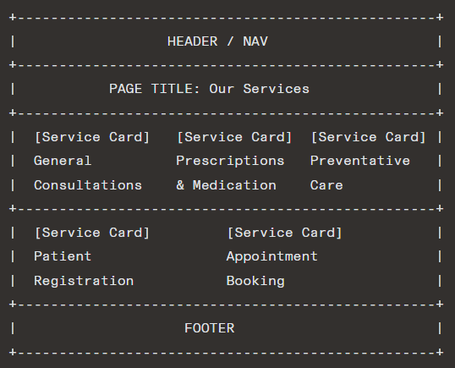
Figure 3: Services Page Wireframe

Enquiry (enquiry.html)
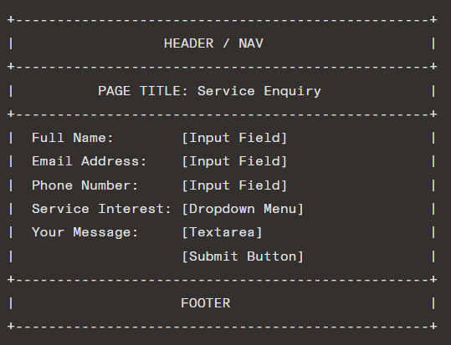
Figure 4: Enquiry Page Wireframe

Contact (contact.html)
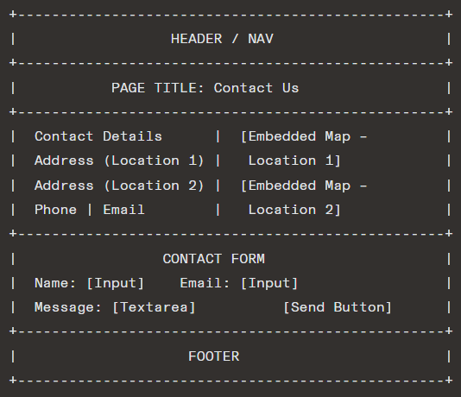
Figure 5: Contact Page Wireframe

Staff Dashboard (dashboard.html)
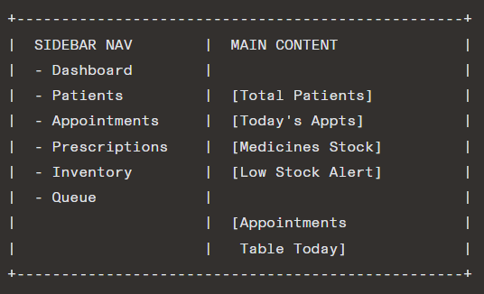
Figure 6: Staff Dashboard Page Wireframe

Technical Requirements

Programming Languages and Frameworks

Technology | Purpose
HTML5 | Structuring all web pages using semantic elements (header, nav, main, section, footer).
CSS3 | Styling all pages, implementing responsive layouts using Flexbox and CSS Grid, and managing visual branding.
JavaScript (Vanilla JS) | Implementing all interactive functionality, CRUD operations, form validation, and dynamic content rendering.
Local Storage  (Mbonane, et al., 2023)  (Shojaei, et al., 2024)  (OWASP, 2026) | Storing and retrieving all patients, appointment, prescription, inventory, and queue data on the client side without a backend server.
JSON  (Mbonane, et al., 2023)  (Shojaei, et al., 2024) | Providing sample and preloaded data for demonstrating system functionality.
Table 5: The Programming Languages and their purpose

Hosting and Domain Requirements

Requirement | Details
Hosting Type  (Africa, 2021) | Shared hosting (suitable for a static front-end only application).
Domain Name  (Africa, 2021) | A custom domain will be registered, e.g. www.healthcareclinic.co.za
Version Control  (Africa, 2021) | GitHub (private repository) for source code management and version tracking.
Browser Compatibility  (Africa, 2021) | The website will be tested and optimized for Google Chrome, Mozilla Firefox, Microsoft Edge, and Safari.
Hosting Type | Shared hosting (suitable for a static front-end only application).
Domain Name | A custom domain will be registered, e.g., www.healthycareclinic.co.za
Version Control | GitHub (private repository) for source code management and version tracking.
Table 6: Hosting and Domain Requirements

File and Folder Structure

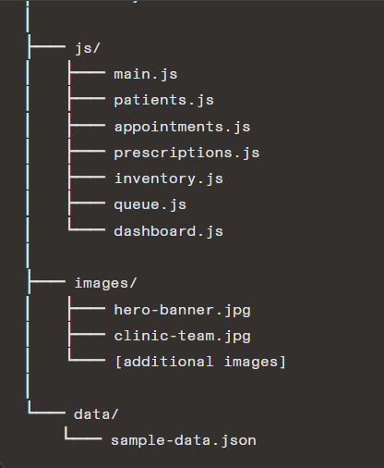
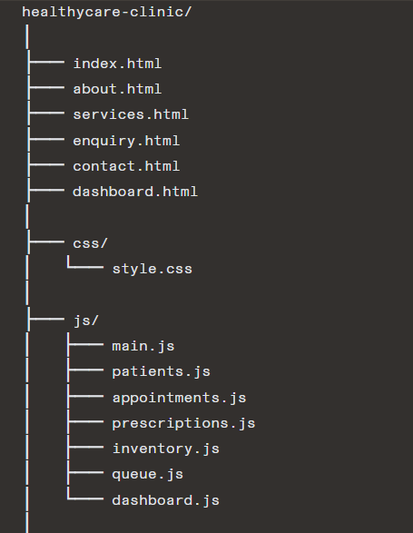
Figure 7: File Structure

Timeline and Milestones

The following project timeline outlines the key milestones and deliverables for the development of the Healthcare Clinic website and management system:
Week | Milestone | Deliverables
Week 1 | Project Proposal | Completed and submitted Website Project Proposal document.
Week 2 | Content Research and Sourcing | Research on clinic services, imagery, content, and font/icon sources. All content organised in project folder structure.
Week 3 | HTML Development | Creation of all HTML pages (index, about, services, enquiry, contact, dashboard) with semantic structure and integrated content.
Week 4 | CSS Styling | Application of all CSS styling, color scheme, typography, responsive layout, and Flexbox/Grid implementation.
Week 5 | JavaScript and Functionality | Implementation of all JavaScript modules: Patient Registration, Appointment Booking, Prescription Tracker, Medicine Inventory, Queue Management, and Dashboard. Integration with Local Storage and JSON data.
Week 6 | Testing and Debugging | Cross-browser testing, form validation testing, responsiveness testing, and bug fixing.
Table 7: Timeline of creating the website

Budget

The following budget provides a realistic estimate of the costs associated with the design, development, hosting, and ongoing maintenance of the Healthcare Clinic website and management system. Budget figures are based on general market research for small business web development in South Africa. (Africa, 2021)
Item | Cost (ZAR) | Frequency | Notes
UI/UX Design  (Africa, 2021) | R 5 500 | Once-off | Includes wireframing, color scheme design, and layout planning.
Front-End Development | R 18 000 | Once-off | Full development of all HTML, CSS, and JavaScript components, including all management modules.
Domain Name Registration | R 200 | Per year + 10% annual increase | Custom .co.za domain (e.g., healthycareclinic.co.za).
Shared Web Hosting | R 1 500 | Per year + 10% annual increase | Shared hosting plans are suitable for a static front-end website.
Content Creation (Images/Icons) | R 0 | Once-off | Free resources sourced from Unsplashed (images) and Font Awesome (icons).
Google Fonts Integration | R 0 | Ongoing | Free via Google Fonts CDN.
Annual Maintenance | R 4 500 | Per year + 10% annual increase | Ongoing updates, content changes, bug fixes, and security checks.
Table 8: Budget Estimation for the Website
Total Estimated Initial Cost: R 29 700 (once-off)
Total Estimated Annual Recurring Cost: R 6 200 per year + 10 % annual increase

Site Map

Figure 8: Site Map

Logo Design


Figure 9: Logo Design

References
Africa, I. R. S., 2021. InfoRegSA-GuidanceNote-Processing-SpecialPersonalInformation-20210628.pdf. [Online]
Available at: https://inforegulator.org.za/wp-content/uploads/2020/07/InfoRegSA-GuidanceNote-Processing-SpecialPersonalInformation-20210628.pdf
[Accessed 2 August 2026].
Awesome, F., 2026. Font Awesome. [Online]
Available at: https://fontawesome.com/
[Accessed 2 August 2026].
Carini, E. et al., 2021. Journal of Medical Internet Research - The Impact of Digital Patient Portals on Health Outcomes, System Efficiency, and Patient Attitudes: Updated Systematic Literature Review. [Online]
Available at: https://www.jmir.org/2021/9/e26189
[Accessed 2 August 2026].
Mbonane, H. et al., 2023. Knowledge, attitudes and practices of healthcare professionals on the use of an electronic stock visibility and management tool in a middle-income country: Implications for access to medicines - ScienceDirect. [Online]
Available at: https://www.sciencedirect.com/science/article/pii/S2667276623000148?via%3Dihub
[Accessed 2 August 2026].
Network, M. D., 2024. CSS: Cascading Style Sheets | MDN. [Online]
Available at: https://developer.mozilla.org/en-US/docs/Web/CSS
[Accessed 30 July 2026].
Network, M. D., 2024. HTML elements reference - HTML | MDN. [Online]
Available at: https://developer.mozilla.org/en-US/docs/Web/HTML/Reference/Elements
[Accessed 30 July 2026].
OWASP, 2026. HTML5 Security - OWASP Cheat Sheet Series. [Online]
Available at: https://cheatsheetseries.owasp.org/cheatsheets/HTML5_Security_Cheat_Sheet
[Accessed 2 August 2026].
Peter J Gates, R.-A. H. ,. M. Z. R. ,. L. L. ,. J. I. W., 2021. How effective are electronic medication systems in reducing medication error rates and associated harm among hospital inpatients? A systematic review and meta-analysis | Journal of the American Medical Informatics Association | Oxford Academic. [Online]
Available at: https://academic.oup.com/jamia/article/28/1/167/5961439
[Accessed 2 August 2026].
Saad, M. et al., 2022. A Comprehensive Analysis of Healthcare Websites Usability Features, Testing Techniques and Issues | IEEE Journals & Magazine | IEEE Xplore. [Online]
Available at: https://ieeexplore.ieee.org/document/9837934
[Accessed 2 August 2026].
Shojaei, P., Vlahu-Gjorgievska, E. & Chow, Y.-W., 2024. Security and Privacy of Technologies in Health Information Systems: A Systematic Literature Review. [Online]
Available at: https://www.mdpi.com/2073-431X/13/2/41
[Accessed 2 August 2026].
W3Schools., 2024. CSS Tutorial. [Online]
Available at: https://www.w3schools.com/css/
[Accessed 30 July 2026].
W3Schools., 2024. HTML Tutorial. [Online]
Available at: https://www.w3schools.com/html/
[Accessed 30 July 2026].
W3Schools., 2024. JavaScript Tutorial. [Online]
Available at: https://www.w3schools.com/js/
[Accessed 30 July 2026].
WCAG, 2024. Web Content Accessibility Guidelines (WCAG) 2.2. [Online]
Available at: https://www.w3.org/TR/wcag/
[Accessed 2 August 2026].
Zhao, P. et al., 2017. Journal of Medical Internet Research - Web-Based Medical Appointment Systems: A Systematic Review. [Online]
Available at: https://www.jmir.org/2017/4/e134/
[Accessed 2 August 2026].

